Chapter 17 – Linked Data Structures – Test Questions
These test questions are fill-in-the-blank, multiple choice, and true false. The multiple-choice questions may have more than one correct answer. Mark all of the correct answers for full credit. True/false questions require an explanation in addition to the true/false response. If the response is false, a correction is required.

True False:
Comment required.
- Insertion into a linked list takes the same number of operations no matter where the insertion occurs
Answer: True
Explanation: Given a pointer to the node in the list prior to position of the new node. In addition to allocation, it will require two operations to insert a node into this list. This is independent of the position in the list.
- A stack is a first-in-first-out data structure.
Answer: False
Explanation: The correct description is first-in-last-out. A stack is unfair. Data items are retrieved in opposite order of arrival.
- A queue is first-in-first-out data structure.
Answer: True
Explanation: A queue is fair. Entries are serviced and removed from the queue in the order of arrival.
- Most applications that use a stack will store a struct or class object on the stack.
Answer: True
Explanation: The struct stored on the stack to store data on the stack. Such a struct is called a stack frame.
- Placing data on a stack is called popping the stack.
Answer: False
Explanation: The correct term is pushing the item onto the stack.
- Removing data from a stack is called popping the stack.
Answer: True
Explanation: Insertion is pushing, removal is popping. Some stacks use void pop operations that merely discards the data removed from the top. Such stacks provide a function to examine the top of the stack. Other stacks remove and return the data on the stack top.
- There is no need for error checking when popping a stack.
Answer: False
Explanation: It is an error to attempt to remove data from an empty stack. Such an error is called a stack underflow.
- There is no need for error checking when pushing a stack.
Answer: False
Explanation: It is an error to attempt to insert data into a stack where no storage space remains. Such an error is a stack overflow.
- Data is inserted into a queue at the back.
Answer: True
Explanation: Just like the lunch line, data is “added” at the back of the queue. Data is serviced at the front, and then removed once service is complete.
- Data is removed at the back of the queue.
Answer: False
Explanation: Data is serviced at the front of the queue, then removed once service is complete.
- A friend class is made to further a sense of community among the students.
Answer: False.
Explanation: Making class F a friend of class C is the equivalent of making every member function of F a friend of class C. The purpose is to grant to F’s member functions access to C’s private data members.
- A tree is a recursive structure.
Answer: True
Explanation: Each tree is composed of two subtrees whose root node are the nodes pointed to by leftLink and rightLink of the root node.
- A hash function maps an object to a unique number.
Answer: False
Explanation: The number is ideally unique, but this is not guaranteed.
- To insert a node into a doubly linked list requires references to the node before and after the location we wish to insert the new node.
Answer: False
Explanation: We only need a reference to the node either before or after the insertion point, and can use the previous or next links to get to the node on the other side of the insertion point.

Multiple Choice
- A linked list is
  - fixed in size
  - can vary in size, shrinking or growing as there is need
  - can be set, and then not changed other than destroying the list
  - none of the above
Answer: b)

- Which of the following are potential problems when we use the delete operator on a pointer variable?
  - inaccessible heap memory
  - dangling pointers
  - uninitialized pointers
  - NULL pointers
Answer:
b) Dangling pointer
Explanation:
A dangling pointer occurs when several pointers point to the same allocated memory, and one of the pointers has the delete operator applied to it. The memory is still there, but it now belongs to the free store manager. The remaining pointers point to deleted memory and are called are dangling. It is common to speak of the deleted pointer as dangling as well, but it might or might not still be pointing at the deleted memory. It is at best an error to delete a pointer that points to already deleted free store memory, and at worst a disaster.

- Which of the following are potential problems when we assign pointer variables:
  - inaccessible heap memory
  - dangling pointers
  - uninitialized pointers
  - NULL pointers
Answer: a) inaccessible memory
Explanation: If only one pointer points to allocated memory, and that pointer has is pointer value changed so that it points some place else, there is no way to access or deallocate (delete) that memory. That memory remains locked up for the life of the program.

- Answer, and explain: For large lists, which of the following is true of inserting a new item into a linked list compared to insertion in an array? What of small lists?
  - more efficient.
  - less efficient.
  - about the same.
  - depends on the size of the two lists.
Answer: The best answer is d) depends on the size of the two lists. For large lists, part a), more efficient is correct, for small lists, part c), about the same is correct.
Explanation: Part a) Inserting a new item into a large linked list is more efficient than insertion into a large array. If we are inserting into a list, you have about 5 operations, most of which are pointer assignments, regardless of the list size. If you insert into an array, on the average, you have to move about half the array entries to insert a data item. For small lists, the answer is c) about the same.

- Answer, and explain: For large lists, deleting an item from a linked list compared to deletion from an array is
  - more efficient.
  - less efficient.
  - about the same.
  - depends on the size of the two lists.
Answer: a) For a large linked list, deletion involves about 3 operations. For a large array, deletion (and the necessary close up of the array) on the average, involves moving about half the array elements.

- The discipline for a stack is:
a) data first inserted is the data first out.
b) for a misbehaving stack, 30 lashes.
c) data last inserted is the data first out.
d) depends on the application of the stack.
Answer. c)
Explanation:
Part a) is for a queue, which we haven't studied, b) is a joke, c) A stack is LIFO, last-in/first-out. Part d) is nonsense.
- Data is removed from a stack in the _____ _______ it was entered.
  - same order
  - reverse order
  - alternating order
  - sorted order

Answer: b) Stack discipline returns data the newest first.

- If a class is declared a friend of another class, typically the classes refer to each other. The classes cannot each be defined before the other. To refer to a class, the class must have been declared. This is accomplished by a
  - Backward declaration
  - Forward declaration
  - Class definition
  - Placing a declaration of one class prior to the definition of the other.
  - None of the above. If the classes are not defined in the order grantor of friendship then friend class, this relationship is impossible.
Answer: Parts b) and d)
Explanation: Part d) is how “it” is done, and part b) is what “it” is called.
- Which of the following is preorder processing for a binary tree?

    - process the right subtree
    - process the root node data
    - process the left subtree

    - process the left subtree
    - process the root node data
    - process the right subtree

    - process the root node data
    - process the left subtree
    - process the right subtree

    - process the left subtree
    - process the right subtree
    - process the root node

    - process the right subtree
    - process the left subtree
    - process the root node
Answer: c)
Explanation: Part b) is in order. Part d) is post order.
- Which of the following is in order processing for a binary tree?

    - process the right subtree
    - process the root node data
    - process the left subtree

    - process the left subtree
    - process the root node data
    - process the right subtree

    - process the root node data
    - process the left subtree
    - process the right subtree

    - process the left subtree
    - process the right subtree
    - process the root node

    - process the right subtree
    - process the left subtree
    - process the root node
Answer: b)
Explanation: Part c) is pre order. Part d) is post order.
- I have a pointer, nodePtr to a node that is a struct in a linked list. I want to access the member named data. I do this using the expression
  - nodePtr.data
  - nodePtr->data
  - *nodePtr.data
  - (*nodePtr).data
  - data is private, you can’t access data under any circumstances.
Answer: b) and d)
Explanation: a) attempts to access a member through a something that is not a class or a struct. nodePtr is pointer, not a struct or class. Part c) gets into precedence trouble. The postfix dot operator binds more closely than the prefix * operator, so we are attempting to access a member in a pointer rather than a struct. Part e) is wrong. The pointer variable nodePtr points to a struct, so access is no problem.

Free Form Questions:
- Given the structure definition:
const int STRING_SIZE = 20;
struct ListNode
{
char item[STRING_SIZE];
int count;
ListNode * link;
};

ListNode *head = new ListNode;

Show two equivalent ways to set the count member in the ListNode variable to which head points.

Answer:
head->count = 12;
(*head).count = 12;

- Given the structure definition:
const int STRING_SIZE = 20;
struct ListNode
{
char item[STRING_SIZE];
int count;
ListNode *link;
};

ListNode *head = new ListNode;
Give code to assign the string "Wilbur's brother Orville" to the member item of the variable to which head points. Hint: you need a function declared in cstring.

Answer: strcpy(head->item, "Wilbur's brother Orville");

- The link field in the last node in a linked list has a special value stored in it. What is it? It has a special name. What is the special name? Why is this done?
Answer: The value is the null pointer. (Not the NULL pointer.) The null pointer value is used to signal the end of the linked list. It is obtained by assigning the value 0 to a pointer variable. When a pointer is assigned the value 0, the C++ type system converts the int value 0 to the implementation dependent value of the null pointer. C++ provides a special preprocessor symbol, NULL, which evaluates to the int value 0 for this use. In C, the value of NULL was an actual pointer value. In C++, the value of NULL is just 0. The bit pattern for the null pointer is not required to be all 0s.

- Given the type definitions:
const int STRING_SIZE = 20;
struct ListNode
{
char item[STRING_SIZE];
int count;
ListNode * link;
};

What is the output produced by the following code? (As always, you are to assume that the code is embedded in a correct and complete program.

ListNode * head = new ListNode;
strcpy( head->item, "Stop Light");
head->count = 10;
cout << (*head).item << endl;
cout << head->item << endl;
cout << (*head).count << endl;
cout << head->number << endl;

Answer:
Stop Light
Stop Light
10
10

- Given the type definitions:
const int STRING_SIZE = 20;
struct ListNode
{
char item[STRING_SIZE];
int count;
ListNode * link;
};
ListNode *head = new ListNode[10];
Show how to return the store allocated by this statement to the heap manager for reallocation.
Answer: delete [] head;

- Given the type definitions:
const int STRING_SIZE = 20;
struct ListNode
{
char item[STRING_SIZE];
int count;
ListNode *link;
};
ListNode *head = new ListNode;

Give a typedef statement that hides the pointer operator *. Call the new type identifier NodePtr.
Answer: typedef Node* NodePtr;

- Here is a diagram of a three node linked list with a head pointer and a node to be inserted. Show all steps necessary to insert the node pointed to by temp between the second and third nodes, including the search for the node prior to insertion. You are to make clear the sequence of steps by either numbering the steps, or by making several copies of this drawing, with one change per drawing, numbered to show the sequence. You may assume a search routine taking a head node and data has been defined for you.
Give code and the drawing to make clear what you are doing.
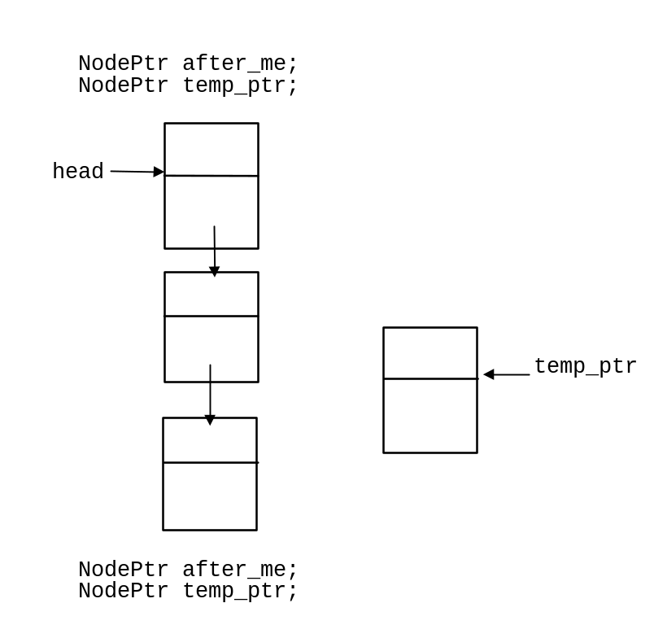
Answer: Although the instructions say to assume the search has been done, I include it, as it really is necessary.

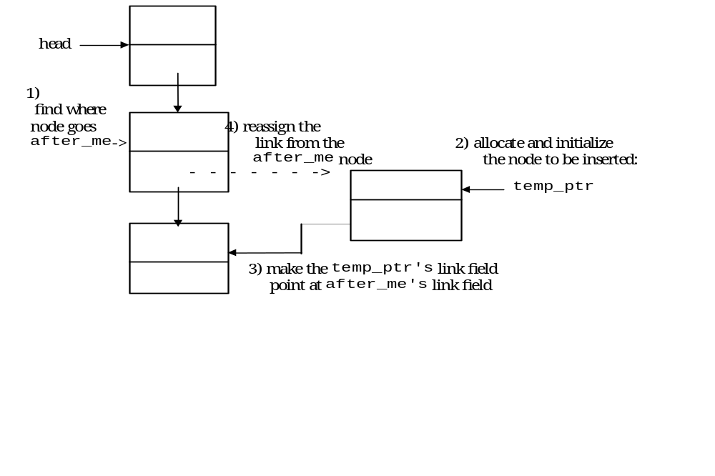
Code:
NodePtr after_me;
NodePtr temp_ptr;
after_me = search(head, target); // 1
temp_ptr = new Node; // 2
temp_ptr->data = data_to_be_added;
temp_ptr->link = after_me->link; // 3
after_me->link = temp_ptr; // 4

- Here is a diagram of a three node linked list with a head pointer and a node to be inserted. Show all steps necessary to delete the second node, pointed to by discard_me. You may assume the necessary search for the node to be deleted is done and the pointer discard_me is already positioned.
You are to make clear the sequence of steps by either numbering the steps, or by making several copies of this drawing, with one change per drawing, numbered to show the sequence.
You may assume that a search routine taking a head pointer and data arguments has been defined for you.
Give code and the drawing to make clear what you are doing.

NodePtr discard_me;
NodePtr temp_ptr;
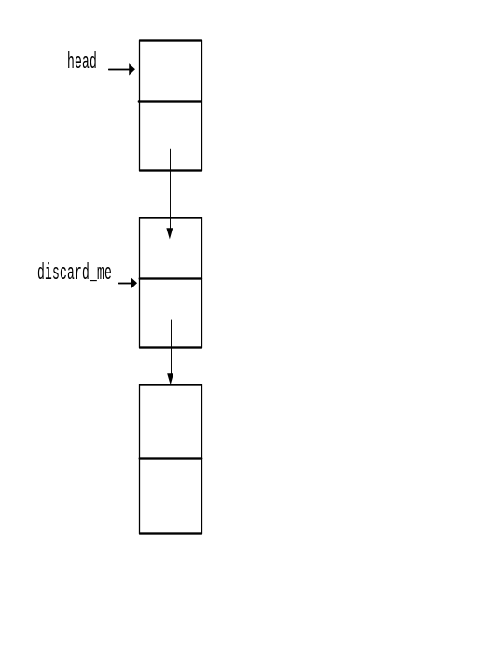
Answer:

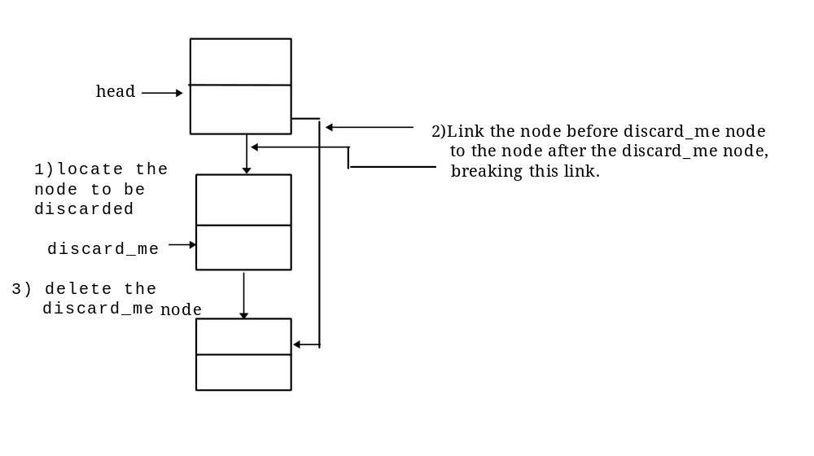
Code:
NodePtr discard_me;
NodePtr temp_ptr;
discard_me = search( head, discard_data);
head->link = discard_me->link;
delete discard_me

- A linked list is normally specified by giving a pointer pointing to the first node of a list. An empty list has no nodes at all. What is the value of a head pointer for an empty list?
Answer: The null pointer value. The null pointer is obtained by assigning the int constant 0 to a pointer variable. C++ provides a preprocessor constant NULL, which evaluates to 0 for use in this situation.

- Suppose you have the following struct definition and typedef statements in your program:
struct N
{
double d;
N *next;
};
typedef N* node_ptr;
node_ptr p1;
Now suppose further that p1 points to a node of type N in a linked list. Write code that makes p1 point to the next node on the linked list.
Answer: p1 = p1->next;
- Suppose you have the following struct definition and typedef statements in your program:
struct N
{
double d;
N *next;
};
typedef N* node_ptr;
node_ptr head, p1, p2;

Now suppose further that p1 points to a node of type N in the middle of a linked list (neither the first nor the last node). Write code that deletes the node after the node p1 points to in the linked list. After the code is executed, the linked list should be the same, excepting the specified node is missing.
Answer:
node_ptr delete_me;
delete_me = p1->next; // delete_me points to the node
//to be deleted
p1->next = delete_me->next;
// node is removed from the list,
//but memory has not been
//deallocated
delete delete_me;
// memory has been recycled

- Name the stack operations as implemented in the text. Tell what each does.
Answer: The push operation puts the argument on the stack. The pop member function checks for empty stack, if non-empty, then pop removes the top item from the stack and returns it, if the stack is empty, pop terminates the program. The empty member function returns true if there is nothing on the stack.

- Give pseudocode for inserting a node in front of the head node in a linked list.
Answer:
1) Create a dynamic variable for the node to be inserted, pointed to by temp_ptr:
temp_ptr = new NodeType;
2) Set the data members of the node
3) make the link field of the new node point to the first node (head node) of the list.
4) make the head pointer point to the new node.

- Why can a raw pointer be used as an iterator for an array, but not for a list?
Answer: Because the pointer arithmetic operations do exactly what you need to traverse an array. Incrementing a pointer to a position an array makes the pointer point to the next position in the array. Incrementing a pointer to a node in a linked list probably does not make the pointer point to the next node. To do this requires more machinery.
- Which of these operations does an iterator class typically have?
  - Overloaded increment and decrement operators to move the next node forward or backward, respectively.
  - Overloaded binary operator* to multiply two iterators.
  - Overloaded operator== to compare iterators and return true if the iterators point to the same item.
  - Overloaded operator&& to perform logical operations on two iterator.
  - Overloaded operator!= to compare iterators and return false if the iterators do not point to the same item.
  - Overloaded unary operator* that returns the item to which the iterator points.
Answer: Parts a) c) e)and f) are correct.
- Which of the following does a binary tree have?
  - A root node
  - Links that point back to its predecessor in the tree.
  - Inaccessible nodes
  - A leaf node or nodes
  - Null pointers on the leaf links
  - Exactly two links at each node.
Answer: a) d) e) and f)
Explanation: The text’s discussion states that a tree can have no cycles and a path from the root to every node. This prohibits c) and d).
- Given the doubly linked list in the diagram below, give the code to delete the second node in the list with the number 31. Assume each entry in the list is a node of class Node with a public next and prev member variable.
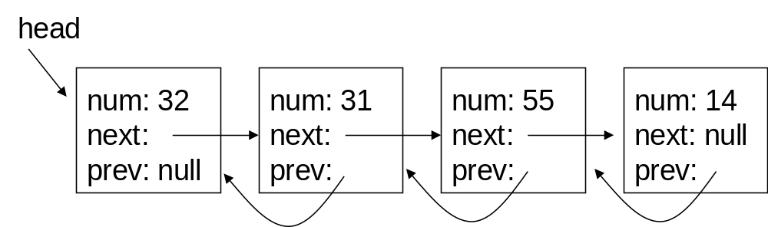
Answer:
Node *toDelete = head->next;
head->next->next->prev = head;
head->next = toDelete->next;
delete toDelete;

- Describe why a very large hash table will likely increase the performance (i.e. faster additions and lookup) at the expense of wasting memory, and vice versa, why a small hash table will use less memory but result in a decrease in performance.
Answer:
A larger hash table decreases the chance of a collision. At every collision point we end up performing a linear search through a linked list. In the worst case, if every item hashed to the same number we would store everything in a single linked list. In the best case the hash table is large enough so that only a single item is stored at every hash location.

